Test Case: tc001_SPX_Dev5_Crear_Solicitud_Articulo_Almacen
Step 1 - Enter username and password and click to button Enter : Credentials Entered
Image file-name: QC_Testing-tc001_SPX_Dev5_Crear_Solicitud_Articulo_Almacen-1787870862338

Step 2 - Select to UEN and Access to Request for a New Inventory Item : UEN Correctly selected and Correct access
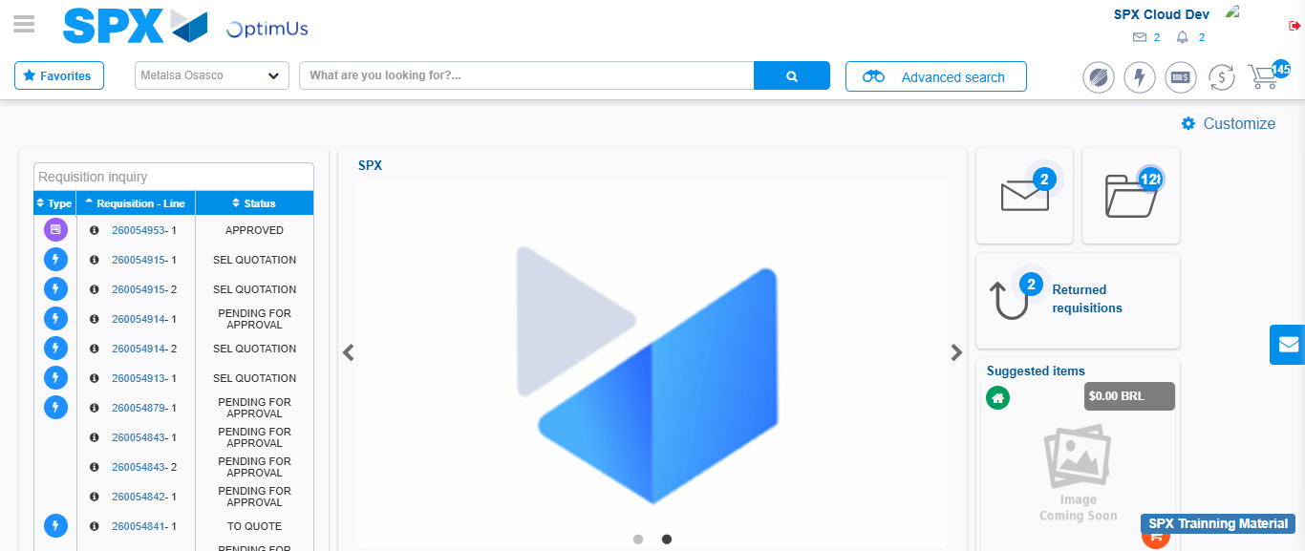Image file-name: QC_Testing-tc001_SPX_Dev5_Crear_Solicitud_Articulo_Almacen-1787870887733

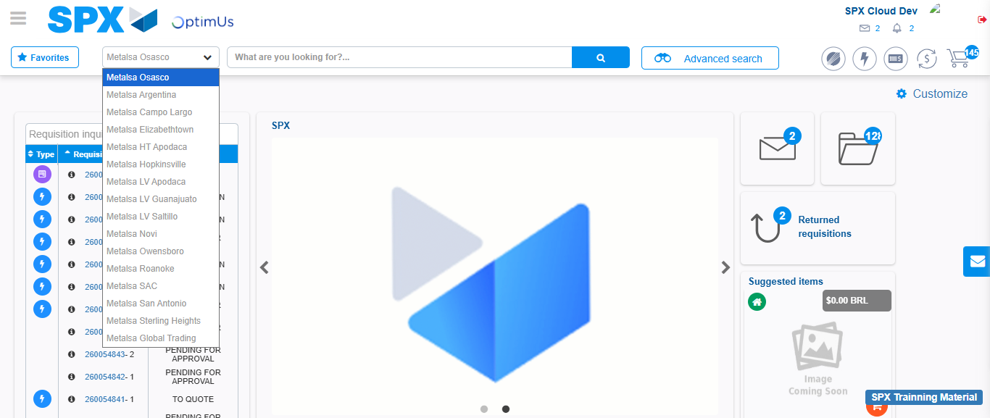Image file-name: QC_Testing-tc001_SPX_Dev5_Crear_Solicitud_Articulo_Almacen-1787870888231

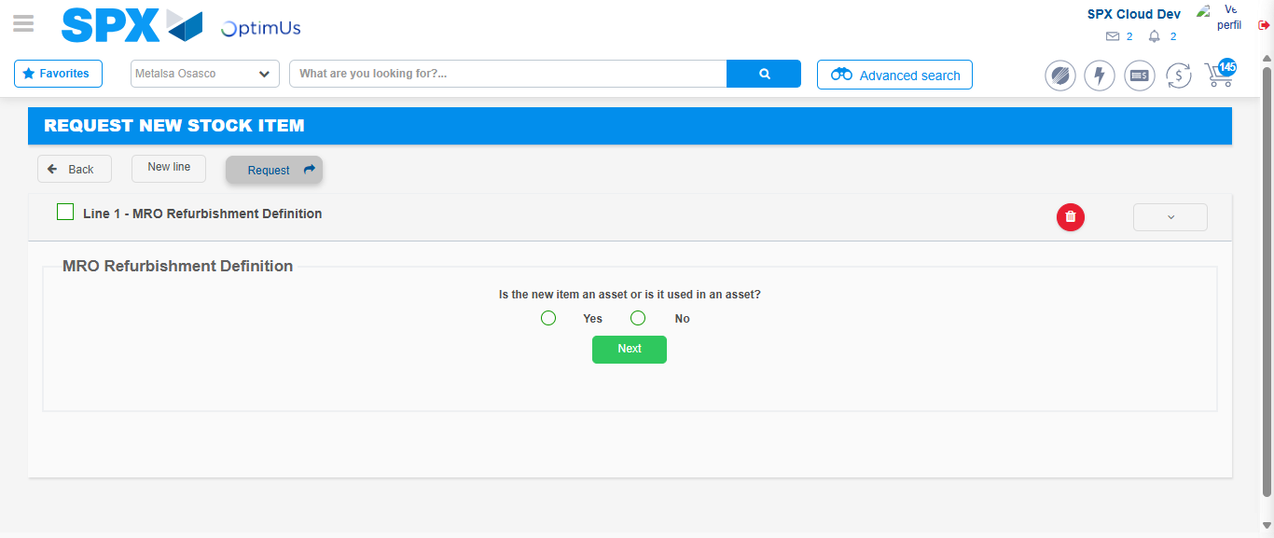Image file-name: QC_Testing-tc001_SPX_Dev5_Crear_Solicitud_Articulo_Almacen-1787870911820

Step 3 - Select options first section : Options seleted correctly
Image file-name: QC_Testing-tc001_SPX_Dev5_Crear_Solicitud_Articulo_Almacen-1787870912057

Image file-name: QC_Testing-tc001_SPX_Dev5_Crear_Solicitud_Articulo_Almacen-1787870912244

Step 4 - Select options at Screen: Options seleted correctly
Image file-name: QC_Testing-tc001_SPX_Dev5_Crear_Solicitud_Articulo_Almacen-1787870912057

Image file-name: QC_Testing-tc001_SPX_Dev5_Crear_Solicitud_Articulo_Almacen-1787870912244

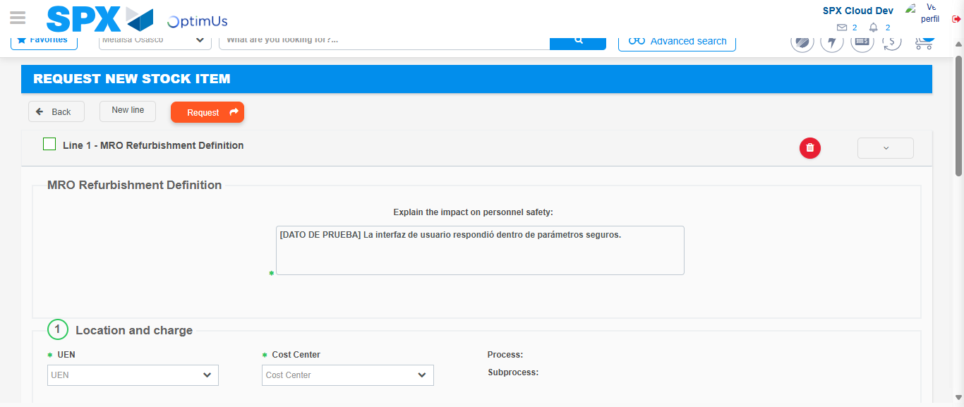Image file-name: QC_Testing-tc001_SPX_Dev5_Crear_Solicitud_Articulo_Almacen-1787870918072

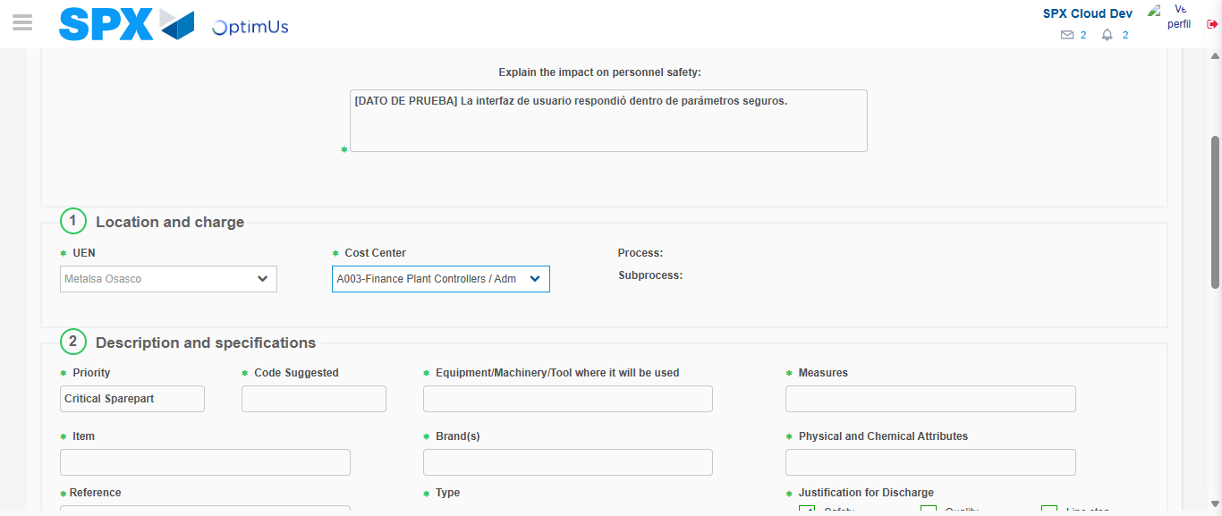Image file-name: QC_Testing-tc001_SPX_Dev5_Crear_Solicitud_Articulo_Almacen-1787870919949

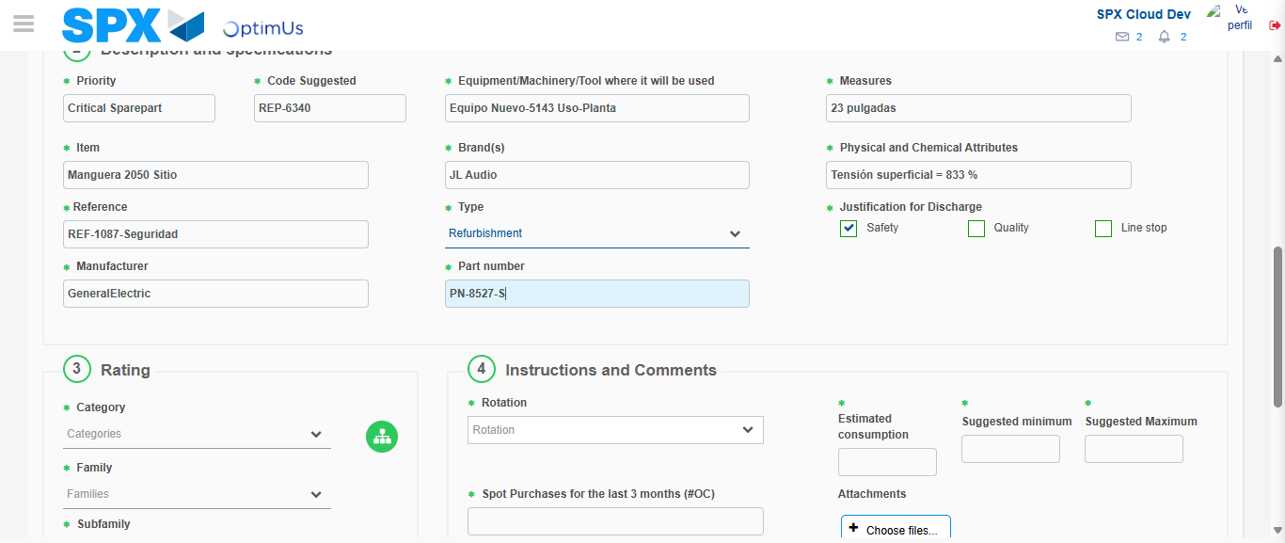Image file-name: QC_Testing-tc001_SPX_Dev5_Crear_Solicitud_Articulo_Almacen-1787870921272

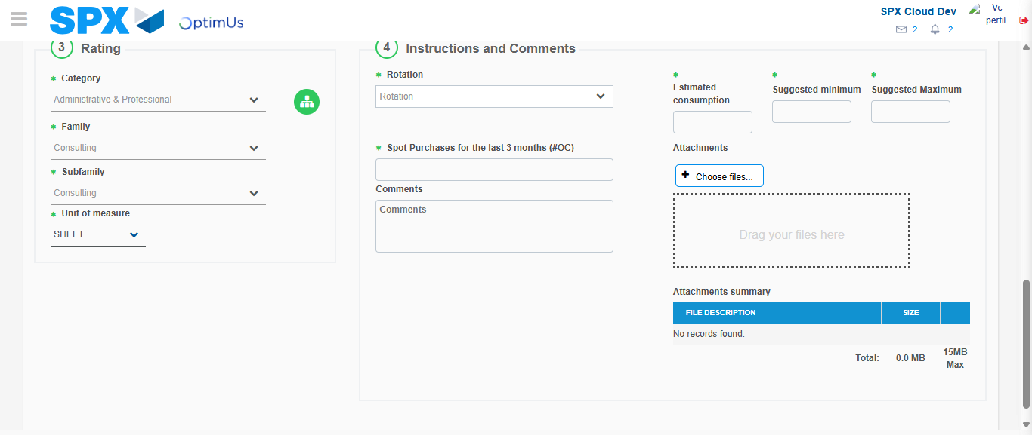Image file-name: QC_Testing-tc001_SPX_Dev5_Crear_Solicitud_Articulo_Almacen-1787870924853

Step 5 - Request New Item : Request Accepted
Image file-name: QC_Testing-tc001_SPX_Dev5_Crear_Solicitud_Articulo_Almacen-1787870887733

Image file-name: QC_Testing-tc001_SPX_Dev5_Crear_Solicitud_Articulo_Almacen-1787870888231

Image file-name: QC_Testing-tc001_SPX_Dev5_Crear_Solicitud_Articulo_Almacen-1787870911820

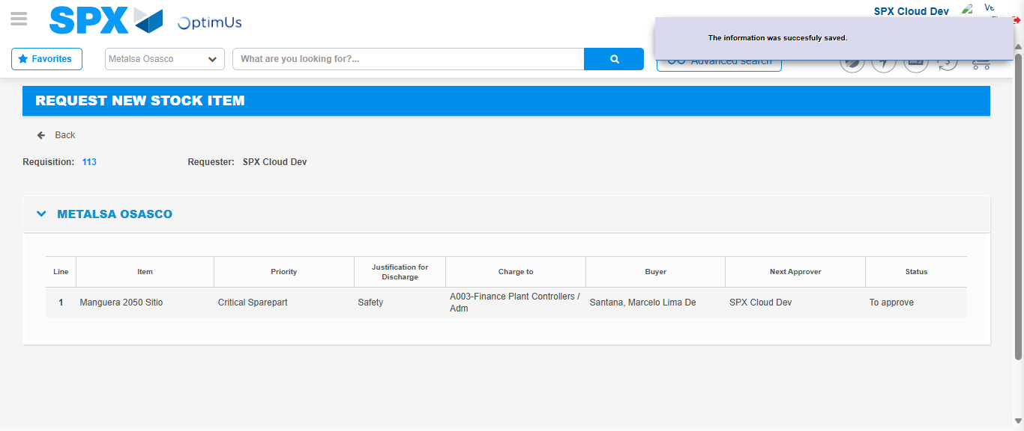Image file-name: QC_Testing-tc001_SPX_Dev5_Crear_Solicitud_Articulo_Almacen-1787870931419

Image file-name: QC_Testing-tc001_SPX_Dev5_Crear_Solicitud_Articulo_Almacen-1787870931598

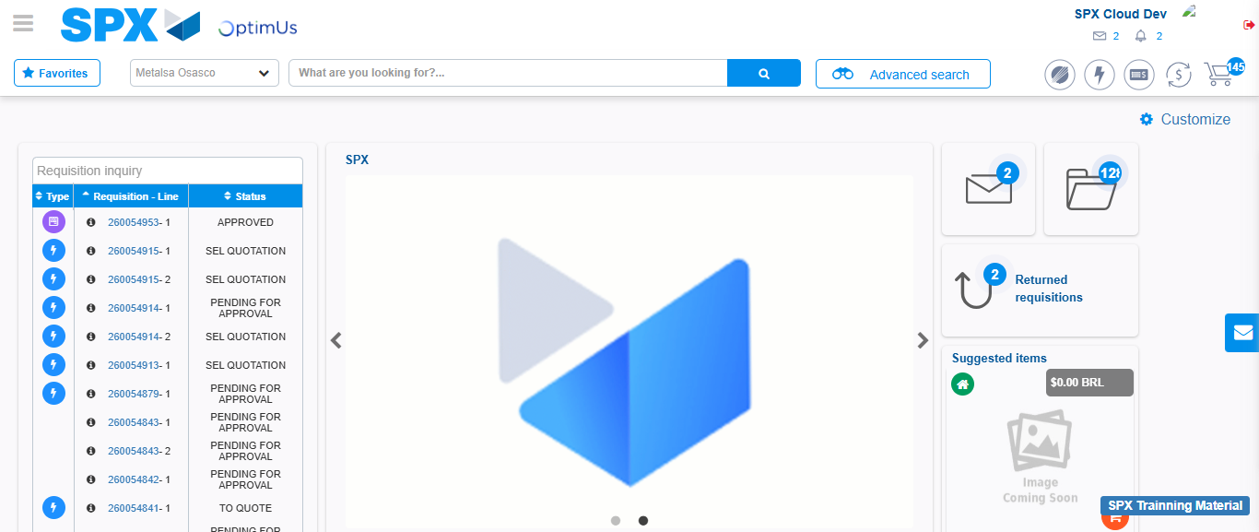Image file-name: QC_Testing-tc001_SPX_Dev5_Crear_Solicitud_Articulo_Almacen-1787870952736

Step 7 - Return to Main Page SPX : Return to Main Page SPX
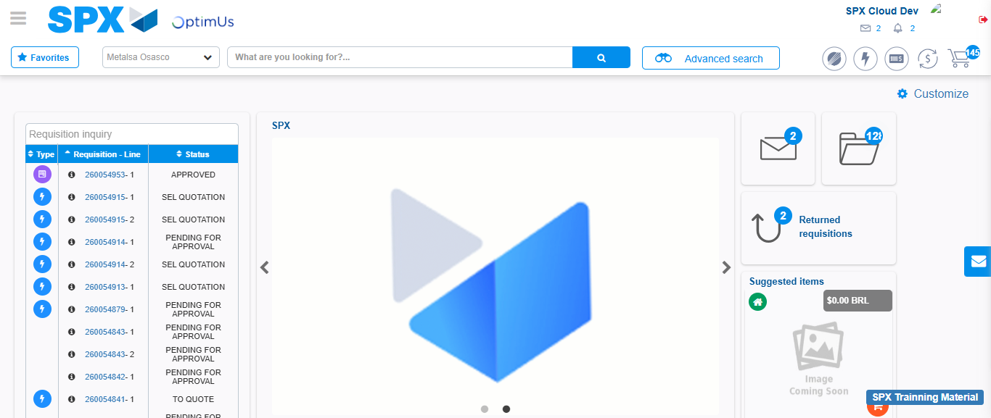Image file-name: QC_Testing-tc001_SPX_Dev5_Crear_Solicitud_Articulo_Almacen-1787870953003

